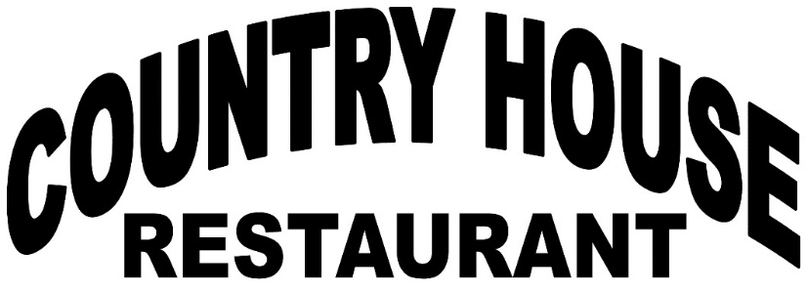
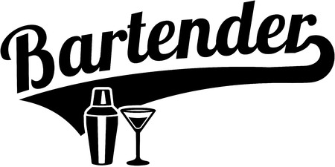

You’re invited to join…
Steve Nero

Thursday, September 12th 7:30 – 9:30
As he Guest Bartends at
The Clarendon Hills Country House
To benefit The Westmont
Knight of Columbus

Country House – Clarendon Hills
241 55th Street
Clarendon Hills, IL
630-325-1444

